**INTERN SCREENSHOT**

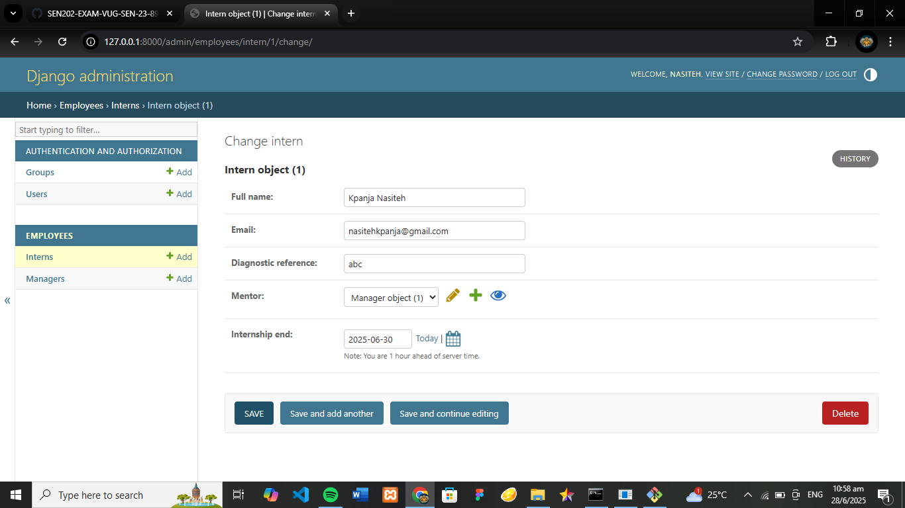

**MANAGER SCREENSHOT**

